**EXPERIMENT NO. 3 IMPACT OF JET**

**Objective:**

To verify the momentum equation experimentally through impact of jet experiment.

**Apparatus Required:** Impact of jet apparatus, weights and stop watch.

**Theory:**

The momentum equation based on Newton’s 2nd law of motion states that the algebraic sum of external forces applied to control volume of fluid in any direction equal to the rate of change of momentum in that direction.

The external forces include the component of the weight of the fluid and of the forces exerted externally upon the boundary surface of control volume.

If a vertical water jet moving with velocity ‘V’ made to strike a target (Vane) which is free, to move in vertical direction, force will be exerted on the target by the impact of jet.

Applying momentum equation in z- direction, force exerted by the jet on the vane, Fz is given by

F = ρQ (Vzout- VZ in)

For flat plate, Vz out= 0

Fz = ρQ (0-v)

FZ = ρQv

For hemispherical curved plate, vz out= -v, vz in= v

Fz = ρQ [v+ (-v)]

FZ = 2ρQv

Where Q= Discharge from the nozzle (Calculated by volumetric method)

V= Velocity of jet = (Q/A)

**Experimental setup:**

The set up primarily consists of a nozzle through which jet emerges vertically in such a way that it may be conveniently observed through the transparent cylinder. It strikes the target plate or disc positioned above it. An arrangement is made for the movement of the plate under the action of the jet and also because of the weight placed on the loading pan. A scale is provided to carry the plate to its original position i.e. as before the jet strikes the plate. A collecting tank is utilized to find the actual discharge and velocity through nozzle.

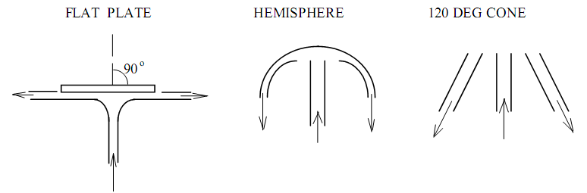

**Fig No. 1 Impact of Jet**

**Procedure**:

1. Note down the relevant dimensions as area of collecting tank and diameter of nozzle.
2. When jet is not running, note down the position of upper disc or plate.
3. Admit water supply to the nozzle.
4. As the jet strikes the disc, the disc moves upward, now place the weights to bring back the upper disc to its original position.
5. At this position find out the discharge and note down the weights placed above the disc.
6. The procedure is repeated for different values of flow rate by reducing the water supply in steps.

**Observation**:

Diameter of nozzle (d) = 10 mm

Area of the nozzle (A) = πd2/4

Mass density of water = 1gm/cm3

Area of collecting tank = 1200cm2

When jet is not running, position of upper disc = ......................... cm

**Observation Table:**

|  |  |  |  |  |  |  |  |  |  |  |
| --- | --- | --- | --- | --- | --- | --- | --- | --- | --- | --- |
| **Sl.**  **No.** | **Discharge/ Velocity measurement** | | | | | **Balancing** | | **Fz =**  ρ**Qv**  **(Dyne)** | **Error (%)** |  |
|  | **Initial**  **(cm)** | **Final**  **(cm)** | **Time**  **(sec)** | **Discharge (Q)**  **(cm3/s)** | **Jet velocity**  **(v)**  **(cm/s)** | **Mass**  **(m)** | **Force**  **F= mg**  **(dyne)** |
| 1. |  |  |  |  |  |  |  |  |  |
| 2. |  |  |  |  |  |  |  |  |  |
| 3. |  |  |  |  |  |  |  |  |  |
| 4. |  |  |  |  |  |  |  |  |  |

**Results & Discussion**

1. Find the theoretical force & error in balancing.

**Precaution:**

1. Apparatus should be in leveled condition.
2. Reading must be taken in steady conditions.
3. Discharge must be varied very gradually from a higher to smaller value.